Paul Jackson Pollock

Student
Institution of Affiliation
Professor
Date

Jackson Pollock
Paul Jackson Pollock, born January 28, 1912, in Cody, Wyoming, U.S and died in East Hampton, New York, on August 11, 1956, was an American painter who advocated for Abstract Expressionism, an art movement distinguished by free-associative signs in the paint at times referred to as action painting. In his lifetime, Pollock got serious recognition and widespread publicity for the drip technique he used in the creation of his major works. Among his peers, he was admired for his deep unbending commitment towards the art of painting. His works had a significant influence on them, and on various following art movements in the U.S. Notably, he is among the first American painters to get recognition during his lifetime and after as a contemporary European master of modern art of 20th century (Birdsall, 2018).
Early life and work
Pollock was born in a family of 5 boys, him being the youngest. His father was a farmer and a land surveyor in the government while his mother is described as fierce and was quite artistic. Pollock was a needy child, and quite often, he was searching for attention, which he never got. In his youth, his family moved around a lot. At the age of 8, his father left them, and Charles, his older brother, took the role of a father to him. He was an artist and was regarded as the best in the family. Notably, Charles had a significant impact on his younger brothers’ ambitions in the future. In Los Angeles, Pollock registered for the Manual Arts high school, discovering his passion for art. He was, however, expelled twice for abandoning school in pursuit of his creativity. He later started studying with Thomas Hart Benton, a representational regionalist painter who was also his brother's art teacher (Peacock, 2018).

Depression-era
In 1935 Pollock was employed as an easel painter by the WPA Federal Art Project. In this position, he had economic security in the years of the great depression, and he also got a chance to develop his art. The regionalist subject matter and compositional methods of his teacher as wells as the American painters Albert Pinkham Ryder poetically expressionist vision greatly influenced his work. His works mostly consisted of small landscapes and metaphorical scenes, including Going West (1934-35), where he made use of motifs taken from photographs of Cody, where he was born (Ratcliff,2019). After the liquidation of the Federal Art Project, Pollock got a contract at the Art of This Century gallery in New York, where he showcased a one-person show. He painted the Mural (c.1943-44), his first work that was wall size. It represents his breakthrough in a personal style where Benton’s methods of compositions are merged with the free associations of unconscious imagery. Pollocks evolution was looking for a way to translate his whole personality through painting. Works including Totem Lesson 1 (1944) The Blue Unconscious (1946) that differs from the Shimmering Substance (1946) and Eyes in the Heat (1946), showing the technique as well as imagery range that he used during this period.
Inspired by Jackson Pollock
“When I am in my painting, I'm not aware of what I'm doing. It is only after a sort of 'get acquainted' period that I see what I have been about. I have no fear of making changes, destroying the image, etc., because the painting has a life of its own. I try to let it come through. It is only when I lose contact with the painting that the result is a mess. Otherwise, there is pure harmony, an easy give and take, and the painting comes out well.” Is one of Jackson Pollocks' famous quotes that has continued to inspire people long after he was gone. He tackled his work fearlessly, going around each work from all angles and was able to be taken entirely by the whole process. Many contemporary artists continue being inspired by Pollock's oeuvre. Withal, his after work was what he became known for, which is the drip technique.
Jonas Fisch, a Los Angeles based; Swedish born artist, creates large paintings inspired by street artists, including Jackson Pollock. He uses both imagery and text. Fisch paints with pointed analysis embedded in every one of his works. Tyler O Thomas is another artist that draws inspiration from Jackson Pollock's work. She views her paintings as an ever-changing story. Every layer adds a new element that is showcasing her mental, physical and spiritual explorations of affairs she goes through. Pollocks style of art is recognizable effortlessly and keeps on inspiring numerous artists with spontaneity being the core of their works as it was to Pollock (Birdsall,2018).
Creative context of Poured Works
Pollock first used the purring or dripping paint to a flat canvas in stages process in 1947. He alternated weeks of painting with the ones of contemplating before he could finish a canvas. This process permitted him to record the scope and force of his physical gestures in courses of aluminum paint. A whole series of paintings with an example of the Full Fathom Five (1947) display the expression he gained in the poured painting. The art is a metaphor of the human’s mind even though it shines and glitter in appearance, under the surface, the mixture and randomness of the anatomy show the apprehensive and humanity’s dark mind (Coddington et al.,2017).
Convergence in the historical context
Convergence is a piece of art that exemplified the Pollocks style of painting as an innovative development in paintings history. During its painful time, the U.S took the cold war with Russia and Communism threat very seriously. The work of art represented by Convergence was that of freedom of expression as well as speech. Pollock rebelled against society's oppressions constraints. It was all that America sided with. Even though his work was hard to decode, his rebellious nature and freedom of expression were evident (Granger,2019).
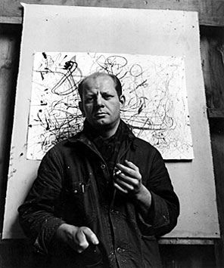 Paul Jackson Pollock (1912-1956).
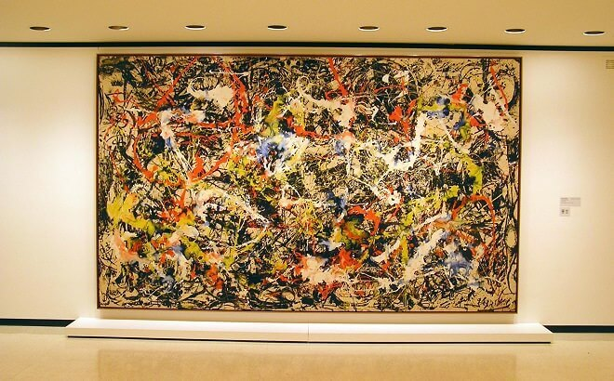 Convergence
Location: Albright-Knox Art Gallery
Dimensions: 237 cm × 390 cm (93.5 in × 155 in)
Created: 1952

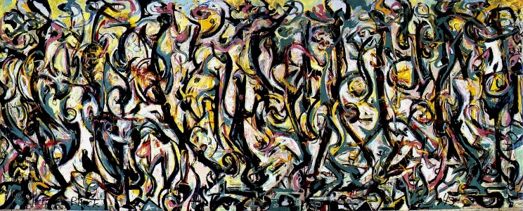 Mural
Location: University of Iowa Stanley Museum of Art
Dimensions: 2.43 by 6.04 meters
Created: 1943

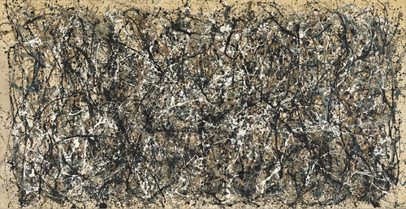 One: Number 31, 1950
Location: Museum of Modern Art (MoMA) in New York City
Dimensions: 2.7 m x 5.31 m
Created: 1950–1950

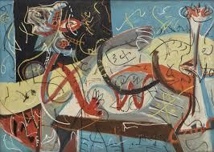 Stenographic figure
Location: Museum of Modern Art, New York
Dimensions: 1.02 m x 1.42 m
Created: 1942
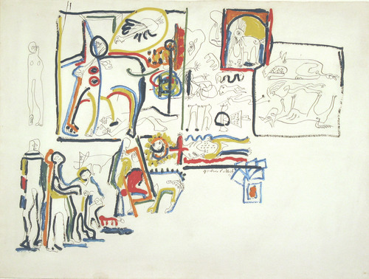 Animal and Figures
Location: Museum of Modern Art, New York
Dimensions: 22 1/2 x 29 7/8" (57.1 x 76 cm)
Created: 1942

References
Birdsall, W. F. (2018). Jackson Pollock’s Classic Paintings: Threading the Camusian Void.
Coddington, J., & Hickey, J. (2017). Seeking Aesthetic Balance: The Restoration of Three Jackson
Granger, D. (2019). The legacy of John Dewey’s Art as experience: Thomas Hart Benton and Jackson Pollock. Studi di estetica, (13).
Pollock Paintings. Getty Research Journal, 9(S1), 79-98.
Peacock, M. (2018). High or Low? The Value of Transitional Paintings by Jackson Pollock, Willem de Kooning, and Mark Rothko.
Ratcliff, C. (2019). The fate of a gesture: Jackson Pollock and postwar American art. Routledge.

